# Proactive disclosure in respect of NACIN, Zonal Campus, Chandigarh under Section 4 (1) (b) of RTI Act, 2005

## Particulars of Organization, Functions and Duties.

* 1. National Academy of Customs, Indirect Taxes & Narcotics (NACIN), functioning under the administrative control of Central Board of Indirect Taxes & Customs (CBIC), Department of Revenue, Ministry of Finance, is the apex institution of Government of India for capacity building in the field of Customs, Indirect Taxes and Narcotics. The headquarters of NACIN is at Palasamudram. Zonal campuses are spread over different parts of country. NACIN Chandigarh was set up at Chandigarh consequent to restructuring and reorganization exercise undertaken by the Central Board of Indirect Taxes & Customs (CBIC), erstwhile CBEC, in May, 2017.
  2. This Zonal Campus works under the overall supervision of Principal Director General, NACIN Palasamudram. Zonal Campus at Chandigarh is headed by Additional Director General (JS rank). NACIN Chandigarh imparts training to Officers/Staff in the field of Indirect Taxes (Goods and Service Tax, Customs, Central Excise and Narcotics control administration) and also conducts GST training programmes for the State Government officers from the states of Punjab, Himachal Pradesh, J&K, Haryana, Uttarakhand and Union Territories of Chandigarh and Ladakh. Further, MoUs have also been signed with State GST Haryana and PAG Punjab to accomplish the same. NACIN plays a key role in capacity building in the area of Customs and GST, enabling the field officers to develop requisite skills for keeping pace with the current international developments and the changing tax administration scenario in the country.
  3. The charter of functions of NACIN is specified in CBIC Office Order No. 06/Ad IV/2017 dated12.06.2017, issued vide F.No A-11012/172017-Ad IV. NACIN ZC Chandigarh undertakes following capacity building activities in the field of Customs, Indirect taxes and Narcotics:
     1. Induction training of directly recruited Inspectors and promoted inspectors, Tax Assistants and Executive Assistants and LDCs under Chandigarh CGST Zone of CBIC;
     2. Specialized and periodic training to in-service officers/ staff;
     3. Training of State Government GST officers from the states of Punjab, Himachal Pradesh, J&K, Haryana, Uttarakhand and Union Territories of Chandigarh and Ladakh;
     4. Management and soft-skill training for overall professional and personal development of officers/ staff;
     5. Any other capacity building activity, as may be assigned by Principal DG NACIN Palasamudram from time to time.

# Powers and duties of its officers and employees

The zonal campus’s main function is to impart training on Customs, indirect taxes, Narcotics laws and related areas to all officers and staff in its jurisdiction. Further this zonal campus is also engaged in GST training of state Government officers, from the states of Punjab, Himachal Pradesh, J&K, Haryana, Uttarakhand and Union Territories of Chandigarh and Ladakh. Annual training calendar for a financial year is prepared around March in the previous financial year, based upon inputs and training needs indicated by field formations under jurisdiction of Chandigarh zone of CBIC. These courses are conducted by inviting faculties from the Department as well as from outside. Eminent persons from different backgrounds are invited to deliver lectures to the participants.

# Procedure followed in decision making process, including channels of supervision and accountability

The courses are conducted under the overall supervision of the Additional Director General with the assistance of Additional/ Joint Director and Deputy/ Assistant Director and with the support of Additional Assistant Director and Inspectors.

# Norms set by it for discharge of its functions:-

Trainings are organized based on requirements and needs of the field formations. Training schedules are drawn up on annual basis for conducting the trainings. Details of prospective trainings to be held during a financial year are available on the website of NACIN Palsamudram (<https://nacin.gov.in/page/trainingcalendar>)

# Rules, regulations, instructions, manuals and records held by it or under its control for being used by the employees for discharging its functions:

Training Programs are conducted on the basis of Acts, Rules, regulations, instructions, manuals etc. published by the Government/CBIC.

# A statement of the categories of documents that are held by it or under its control:

All records pertaining to administration, establishment and trainings organized along with documents that get generated during trainings.

## The particulars of any arrangement that exists for consultation with, or representation by the members of the public in relation to the formulation of its policy or implementation there of:

Not applicable. There is no public dealing in the Academy.

## A Statement of the Boards, Councils, Committees and other bodies consisting of two or more persons constituted as its part or for the purpose of its advice, and as to whether meetings of those Boards, Councils, Committees and other bodies are open to the public, or the Minutes of such meetings are accessible for public:

Not Applicable.

1. **Directory of its officers and employees**

**Zonal Campus, Chandigarh**

|  |  |  |  |  |
| --- | --- | --- | --- | --- |
| **Sr.No.** | **Nameofthe officers** | **Designation** | **Telephone** | **Level in the pay matrix** |
| 1. | Shri Sunil Kumar Katiyar | Additional Director General | 0172-2721103 | 14 |
| 2. | Ms.Varinder Kaur | Additional Director | 0172-2991050 | 13 |
| 3. | Shri Varun Soni | Deputy Director |  | 11 |
| 4. | Shri Bhupesh Satija | Deputy Director |  | 11 |
| 5. | Shri Baljit Singh Khara | Assistant Director |  | 10 |
| 6. | Shri Rajesh Roy | Assistant Director |  | 10 |
| 7. | Smt. Monika Sharma | Chief Accounts Officer (additional charge) |  | 10 |
| 8. | Shri Swajesh Gupta | Additional Assistant Director |  | 9 |
| 9. | Shri Vijay Bansal | Additional Assistant Director |  | 9 |
| 10. | Shri Vinod Kumar | Additional Assistant Director |  | 8 |
| 11. | Smt. Pansy Gupta | Additional Assistant Director |  | 8 |
| 12. | Smt. Shikha Nimesh | Additional Assistant Director |  | 8 |
| 13. | Shri Amit Kumar | Inspector |  | 7 |
| 14. | Ms. Kiran K Lal | PS |  | 7 |
| 15. | Shri Pariansh Mittal | Executive Assistant |  | 6 |
| 16. | Shri Deepak | Executive Assistant |  | 6 |
| 17. | Shri Navdeep Singh | Executive Assistant |  | 6 |
| 18. | Shri Kuldeep Yadav | Tax Assistant |  | 6 |
| 19. | Shri Sandeep Chauhan | Havaldar |  | 1 |

1. **Monthly remuneration received by each of its officers and employees, including the system of compensation as provided in its regulations:**

All the officers/ employees/ Staff of NACIN Zonal Campus draw their monthly emoluments as per Government pay rules. The indicative monthly pay for each level is given below:

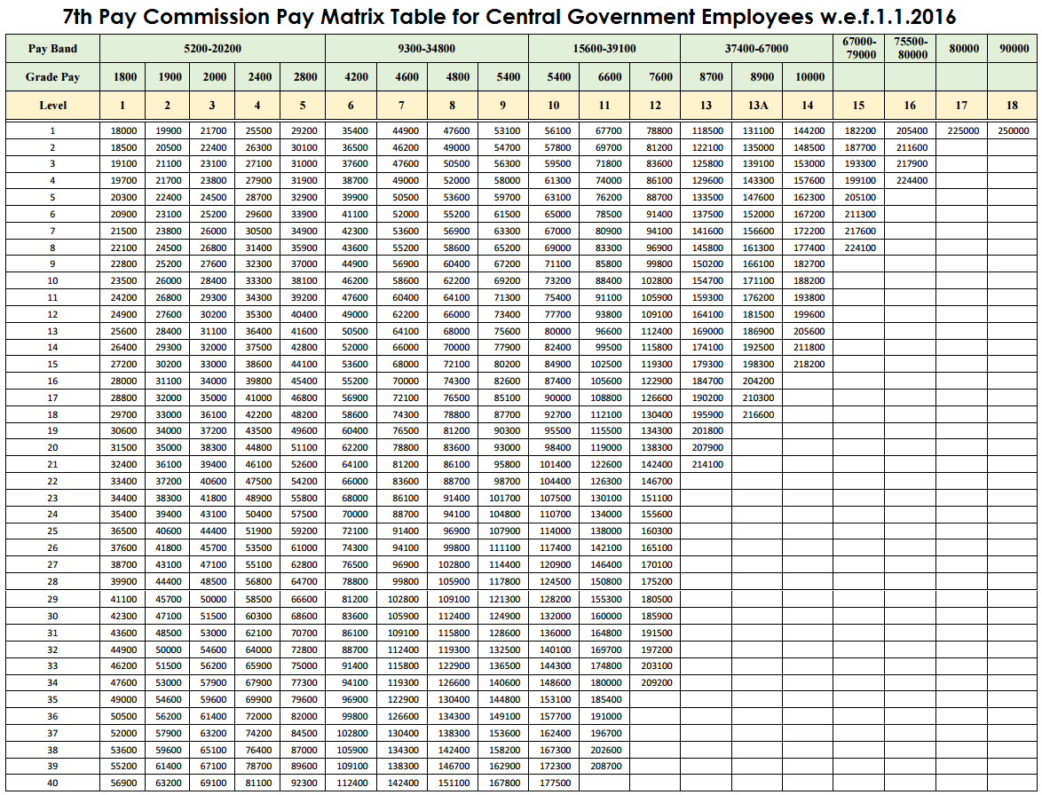

## Budget allocated to each of its agency, indicating the particulars of all plans, proposed expenditure and reports on disbursements made:

Annual budget is allocated to the ZTI. The budget allocation for 2023-24 was Rs 2.80 crores and expenditure was Rs 2.63 crores. Budget allocation for 2024-25 is Rs 2.40 crores.

## The manner of execution of subsidy programmes, including the amounts allocated and the details of beneficiaries of such programmes:

Not Applicable to this Academy.

## Particulars of recipients of concessions, permits or authorizations granted by it:

Not Applicable to this Academy

## Details in respect of the information, available to or held by it, reduced in an electronic form:

Entire file work of the ZTI is carried out in electronic mode on e-office.

## The particulars of facilities available to citizens for obtaining information, including the working hours of a library or reading room, if maintained for public use:

Not applicable

## Names, designations and other particulars of the Public Information Officers:

|  |  |  |  |
| --- | --- | --- | --- |
| **S.No.** | **Formation** | **Name of the CPIO & Contact No.** | **Name of Appellate**  **Authority & Contact No.** |
| 1 | NACIN, Zonal Campus, Chandigarh | Shri Rajesh Roy,  Assistant Director  0172-2991050 | Ms. Varinder Kaur, Additional Director  0172-2991050 |

1. **Such other information as may be prescribed:**

Not applicable.